**Name: Deepak Sanjay Baravkar**

**Roll No. BIT06**

**ASSIGNMENT NO. 3**

**Problem Statement:**

To develop any distributed application with CORBA program using JAVA IDL.

**Tools / Environment:**

Java Programming Environment, JDK 1.8

**Related Theory:**

**Common Object Request Broker Architecture (CORBA):**

CORBA is an acronym for Common Object Request Broker Architecture. It is an open source, vendor-independent architecture and infrastructure developed by the **Object Management Group** (**OMG**) to integrate enterprise applications across a distributed network. CORBA specifications provide guidelines for such integration applications, based on the way they want to interact, irrespective of the technology; hence, all kinds of technologies can implement these standards using their own technical implementations.

When two applications/systems in a distributed environment interact with each other, there are quite a few unknowns between those applications/systems, including the technology they are developed in (such as Java/ PHP/ .NET), the base operating system they are running on (such as Windows/Linux), or system configuration (such as memory allocation). **They communicate mostly with the help of each other's network address or through a naming service.** Due to this, these applications end up with quite a few issues in integration, including content (message) mapping mismatches.

An application developed based on CORBA standards with standard **Internet Inter-ORB Protocol** (**IIOP**), irrespective of the vendor that develops it, should be able to smoothly integrate and operate with another application developed based on CORBA standards through the same or different vendor.

Except legacy applications, most of the applications follow common standards when it comes to object modeling, for example. All applications related to, say, "HR&Benefits" maintain an object model with details of the organization, employees with demographic information, benefits, payroll, and deductions. They are only different in the way they handle the details, based on the country and region they are operating for. For each object type, similar to the HR&Benefits systems, we can define an interface using the **Interface Definition Language** (**OMG IDL**).

The contract between these applications is defined in terms of an interface for the server objects that the clients can call. This IDL interface is used by each client to indicate when they should call any particular method to marshal (read and send the arguments).

The target object is going to use the same interface definition when it receives the request from the client to unmarshal (read the arguments) in order to execute the method that was requested by the client operation. Again, during response handling, the interface definition is helpful to marshal (send from the server) and unmarshal (receive and read the response) arguments on the client side once received.

The IDL interface is a design concept that works with multiple programming languages including C, C++, Java, Ruby, Python, and IDLscript. This is close to writing a program to an interface, a concept we have been discussing that most recent programming languages and frameworks, such as Spring. The interface has to be defined clearly for each object. The systems encapsulate the actual implementation along with their respective data handling and processing, and only the methods are available to the rest of the world through the interface. Hence, the clients are forced to develop their invocation logic for the IDL interface exposed by the application they want to connect to with the method parameters (input and output) advised by the interface operation.

The following diagram shows a single-process ORB CORBA architecture with the IDL configured as client stubs with object skeletons, The objects are written (on the right) and a client for it (on the left), as represented in the diagram. The client and server use stubs and skeletons as proxies, respectively. The IDL interface follows a strict definition, and even though the client and server are implemented in different technologies, they should integrate smoothly with the interface definition strictly implemented.

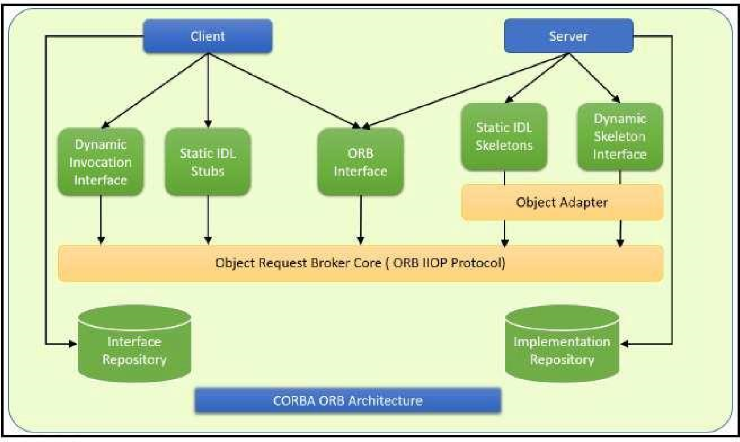

In CORBA, each object instance acquires an object reference for itself with the electronic token identifier. Client invocations are going to use these object references that have the ability to figure out which ORB instance they are supposed to interact with. The stub and skeleton represent the client and server, respectively, to their counterparts. They help establish this communication through ORB and pass the arguments to the right method and its instance during the invocation.

**Inter-ORB communication**

The following diagram shows how remote invocation works for inter-ORB communication. It shows that the clients that interacted have created **IDL Stub** and **IDL Skeleton** based on **Object Request Broker** and communicated through **IIOP Protocol**.

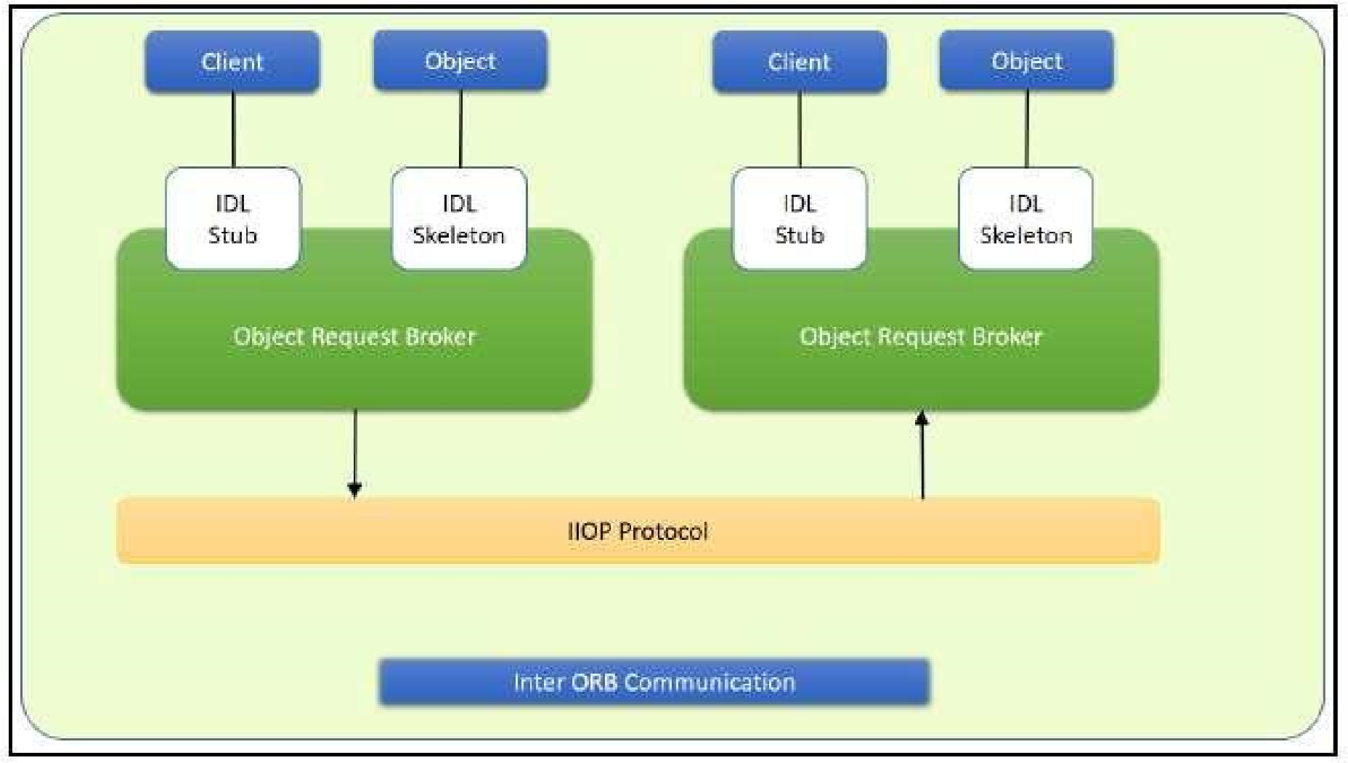

To invoke the remote object instance, the client can get its object reference using a naming service. Replacing the object reference with the remote object reference, the client can make the invocation of the remote method with the same syntax as the local object method invocation. ORB keeps the responsibility of recognizing the remote object reference based on the client object invocation through a naming service and routes it accordingly.

**Java Support for CORBA**

CORBA complements the Java™ platform by providing a distributed object framework, services to support that framework, and interoperability with other languages. The Java platform complements CORBA by providing a portable, highly productive implementation environment, and a very robust platform. By combining the Java platform with CORBA and other key enterprise technologies, the Java Platform is the ultimate platform for distributed technology solutions.

CORBA standards provide the proven, interoperable infrastructure to the Java platform. IIOP (Internet Inter-ORB Protocol) manages the communication between the object components that power the system. The Java platform provides a portable object infrastructure that works on every major operating system. CORBA provides the network transparency, Java provides the implementation transparency. **An *Object Request Broker (ORB)* is part of the Java Platform. The ORB is a runtime component that can be used for distributed computing using IIOP communication. Java IDL is a Java API for interoperability and integration with CORBA.**

Java IDL included both a Java-based ORB, which supported IIOP, and the **IDL-to-Java compiler**, for generating client-side stubs and server-side code skeletons. J2SE v.1.4 includes an **Object Request Broker Daemon (ORBD), which is used to enable clients to transparently locate and invoke persistent objects on servers in the CORBA environment.**

When using the **IDL programming model,** the interface is everything! It defines the points of entry that can be called from a remote process, such as the types of arguments the called procedure will accept, or the value/output parameter of information returned. Using IDL, the programmer can make the entry points and data types that pass between communicating processes act like a standard language.

CORBA is a language-neutral system in which the argument values or return values are limited to what can be represented in the involved implementation languages. In CORBA, object orientation is limited only to objects that can be passed by reference (the object code itself cannot be passed from machine-to-machine) or are predefined in the overall framework. Passed and returned types must be those declared in the interface.

With RMI, the interface and the implementation language are described in the same language, so you don't have to worry about mapping from one to the other. Language-level objects (the code itself) can be passed from one process to the next. Values can be returned by their actual type, not the declared type. Or, you can compile the interfaces to generate IIOP stubs and skeletons which allow your objects to be accessible from other CORBA-compliant languages.

**The IDL Programming Model:**

The IDL programming model, known as Java™ IDL, consists of both the Java CORBA ORB and the idlj compiler that maps the IDL to Java bindings that use the Java CORBA ORB, as well as a set of APIs, which can be explored by selecting the org.omg prefix from the Package section of the API index.

Java IDL adds CORBA (Common Object Request Broker Architecture) capability to the Java platform, providing standards-based interoperability and connectivity. Runtime components include a Java ORB for distributed computing using IIOP communication.

To use the IDL programming model, define remote interfaces using OMG Interface Definition Language (IDL), then compile the interfaces using idlj compiler. When you run the idlj compiler over your interface definition file, it generates the Java version of the interface, as well as the class code files for the stubs and skeletons that enable applications to hook into the ORB.

**Portable Object Adapter (POA) :** An *object adapter* is the mechanism that connects a request using an object reference with the proper code to service that request. The Portable Object Adapter, or POA, is a particular type of object adapter that is defined by the CORBA specification. The POA is designed to meet the following goals:

* Allow programmers to construct object implementations that are portable between different ORB products.
* Provide support for objects with persistent identities.

**Designing the solution:**

Here the design of how to create a complete CORBA (Common Object Request Broker

Architecture) application using IDL (Interface Definition Language) to define interfaces and Java IDL compiler to generate stubs and skeletons. You can also create CORBA application by defining the interfaces in the Java programming language.

The server-side implementation generated by the idlj compiler is the *Portable Servant Inheritance Model*, also known as the POA(Portable Object Adapter) model. This document presents a sample application created using the default behavior of the idlj compiler, which uses a POA server-side model.

1. **Creating CORBA Objects using Java IDL:**

1.1. In order to distribute a Java object over the network using CORBA, one has to define it's own CORBA-enabled interface and it implementation. This involves doing the following:

* Writing an interface in the CORBA Interface Definition Language
* Generating a Java base interface, plus a Java stub and skeleton class, using an IDL-to-Java compiler
* Writing a server-side implementation of the Java interface in Java

Interfaces in IDL are declared much like interfaces in Java.

* 1. **Modules**

Modules are declared in IDL using the module keyword, followed by a name for the module and an opening brace that starts the module scope. Everything defined within the scope of this module (interfaces, constants, other modules) falls within the module and is referenced in other IDL modules using the syntax *modulename*::x. e.g.

// IDL module jen { module corba {

interface NeatExample ...

};

};

* 1. **Interfaces**

The declaration of an interface includes an interface header and an interface body. The header specifies the name of the interface and the interfaces it inherits from (if any). Here is an IDL interface header:

interface PrintServer : Server { ...

This header starts the declaration of an interface called PrintServer that inherits all the methods and data members from the Server interface.

* 1. **Data members and methods**

The interface body declares all the data members (or attributes) and methods of an interface. Data members are declared using the attribute keyword. At a minimum, the declaration includes a name and a type.

readonly attribute string myString;

The method can be declared by specifying its name, return type, and parameters, at a minimum.

string parseString(in string buffer);

This declares a method called parseString() that accepts a single string argument and returns a string value.

* 1. **A complete IDL example**

Now let's tie all these basic elements together. Here's a complete IDL example that declares a module within another module, which itself contains several interfaces:

module OS {

module services {

interface Server {

readonly attribute string serverName; boolean init(in string sName);

};

interface Printable {

boolean print(in string header);

};

interface PrintServer : Server {

boolean printThis(in Printable p);

};

};

};

The first interface, Server, has a single read-only string attribute and an init() method that accepts a string and returns a boolean. The Printable interface has a single print()method that accepts a string header. Finally, the PrintServer interface extends the Server interface and adds a printThis() method that accepts a Printable object and returns a boolean. In all cases, we've declared the method arguments as input-only (i.e., pass-by-value), using the in keyword.

**2. Turning IDL Into Java**

**Once the remote interfaces in IDL are described, you need to generate Java classes that act as a starting point for implementing those remote interfaces in Java using an IDL-to-Java compiler.** Every standard IDL-to-Java compiler generates the following 3 Java classes from an IDL interface:

* A Java interface with the same name as the IDL interface. This can act as the basis for a Java implementation of the interface (but you have to write it, since IDL doesn't provide any details about method implementations).
* A *helper* class whose name is the name of the IDL interface with "Helper" appended to it (e.g., ServerHelper). The primary purpose of this class is to provide a static narrow() method that can safely cast CORBA Object references to the Java interface type. The helper class also provides other useful static methods, such as read() and write() methods that allow you to read and write an object of the corresponding type using I/O streams.
* A *holder* class whose name is the name of the IDL interface with "Holder" appended to it (e.g., ServerHolder). This class is used when objects with this interface are used as out or inout arguments in remote CORBA methods. Instead of being passed directly into the remote method, the object is wrapped with its holder before being passed. When a remote method has parameters that are declared as out or inout, the method has to be able to update the argument it is passed and return the updated value. The only way to guarantee this, even for primitive Java data types, is to force out and inout arguments to be wrapped in Java holder classes, which are filled with the output value of the argument when the method returns.

The idltoj tool generate 2 other classes:

* **A client *stub* class,** called _*interface-name*Stub, that acts as a client-side implementation of the interface and knows how to convert method requests into ORB requests that are forwarded to the actual remote object. The stub class for an interface named Server is called _ServerStub.
* **A server *skeleton* class,** called _*interface-name*ImplBase, that is a base class for a server- side implementation of the interface. The base class can accept requests for the object from the ORB and channel return values back through the ORB to the remote client. The skeleton class for an interface named Server is called _ServerImplBase.

So, in addition to generating a Java mapping of the IDL interface and some helper classes for the Java interface, the *idltoj* compiler also creates subclasses that act as an interface between a CORBA client and the ORB and between the server-side implementation and the ORB.

**This creates the five Java classes: a Java version of the interface, a helper class, a holder class, a client stub, and a server skeleton.**

**3. Writing the Implementation**

The IDL interface is written and generated the Java interface and support classes for it, including the client stub and the server skeleton. Now, concrete server-side implementations of all of the methods on the interface needs to be created.

**Implementing the solution:**

Here, we are demonstrating the "Hello World" Example. **To create this example, create a directory named hello/ where you develop sample applications and create the files in this directory.**

1. **Defining the Interface (Hello.idl)**

The first step to creating a CORBA application is to specify all of your objects and their interfaces using the OMG's Interface Definition Language (IDL).To complete the application, you simply provide the server **(HelloServer.java)** and client **(HelloClient.java)** implementations.

1. **Implementing the Server (HelloServer.java)**

The example server consists of two classes, the servant and the server. The servant, HelloImpl, is the implementation of the Hello IDL interface; each Hello instance is implemented by a HelloImpl instance. The servant is a subclass of HelloPOA, which is generated by the idlj compiler from the example IDL. The servant contains one method for each IDL operation, in this example, the sayHello() and shutdown() methods. Servant methods are just like ordinary Java methods; the extra code to deal with the ORB, with marshaling arguments and results, and so on, is provided by the skeleton.

The HelloServer class has the server's main() method, which:

* Creates and initializes an ORB instance
* Gets a reference to the root POA and activates the POAManager
* Creates a servant instance (the implementation of one CORBA Hello object) and tells the ORB about it
* Gets a CORBA object reference for a naming context in which to register the new CORBA object
* Gets the root naming context
* Registers the new object in the naming context under the name "Hello"
* Waits for invocations of the new object from the client.

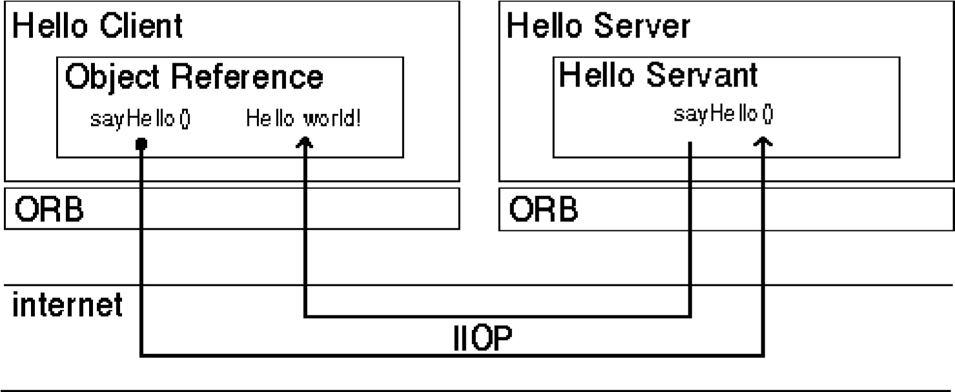

**3. Implementing the Client Application (HelloClient.java)** The example application client that follows:

* Creates and initializes an ORB
* Obtains a reference to the root naming context
* Looks up "Hello" in the naming context and receives a reference to that CORBA object
* Invokes the object's sayHello() and shutdown() operations and prints the result.

**Building and Executing the solution:**

The Hello World program lets you learn and experiment with all the tasks required to develop almost any CORBA program that uses static invocation, which uses a client stub for the invocation and a server skeleton for the service being invoked and is used when the interface of the object is known at compile time.

This example requires a naming service, which is a CORBA service that allows **CORBA objects** to be named by means of binding a name to an object reference. The **name binding** may be stored in the naming service, and a client may supply the name to obtain the desired object reference. The two options for Naming Services with Java include **orbd**, a daemon process containing a Bootstrap Service, a Transient Naming Service,

To run this client-server application on the development machine:

1. Change to the directory that contains the file Hello.idl.
2. Run the IDL-to-Java compiler, idlj, on the IDL file to create stubs and skeletons. This step assumes that you have included the path to the java/bin directory in your path.

**idlj -fall Hello.idl**

You must use the -fall option with the idlj compiler to generate both client and server- side bindings. This command line will generate the default server-side bindings, which assumes the POA Inheritance server-side model.

The files generated by the idlj compiler for Hello.idl, with the -fall command line option, are:

* + HelloPOA.java:

This abstract class is the stream-based server skeleton, providing basic CORBA functionality for the server. It extends org.omg.PortableServer.Servant, and implements the InvokeHandler interface and the HelloOperations interface.

The server class HelloImpl extends HelloPOA.

* + _HelloStub.java:

This class is the client stub, providing CORBA functionality for the client. It

extends org.omg.CORBA.portable.ObjectImpl and implements the Hello.java interface.

* + Hello.java:

This interface contains the Java version of IDL interface written. The Hello.java interface extends org.omg.CORBA.Object, providing standard CORBA object functionality. It also extends the HelloOperations interface and org.omg.CORBA.portable.IDLEntity.

* + HelloHelper.java

This class provides auxiliary functionality, notably the narrow() method required to cast CORBA object references to their proper types. **The Helper class is responsible for reading and writing the data type to CORBA streams, and inserting and extracting the data type from AnyS.** The Holder class delegates to the methods in the

Helper class for reading and writing.

* + HelloHolder.java

This final class holds a public instance member of type Hello. Whenever the IDL type is an out or an inout parameter, the Holder class is used. It provides operations

for org.omg.CORBA.portable.OutputStream and org.omg.CORBA.port able.InputStream arguments, which CORBA allows, but which do not map easily to Java's semantics. The Holder class delegates to the methods in the Helper class for reading and writing. It implements org.omg.CORBA.portable.Streamable.

* + HelloOperations.java

This interface contains the methods sayHello() and shutdown(). The IDL-to-Java mapping puts all of the operations defined on the IDL interface into this file, which is shared by both the stubs and skeletons.

1. Compile the .java files, including the stubs and skeletons (which are in the directory directory HelloApp). This step assumes the java/bin directory is included in your path.

javac *.java HelloApp/*.java

1. Start orbd.

To start orbd from a UNIX command shell, enter:

orbd -ORBInitialPort 1050&

Note that 1050 is the port on which you want the name server to run. The - ORBInitialPort argument is a required command-line argument.

1. Start the HelloServer:

To start the HelloServer from a UNIX command shell, enter:

java HelloServer -ORBInitialPort 1050 -ORBInitialHost localhost&

You will see HelloServer ready and waiting... when the server is started.

1. Run the client application:

java HelloClient -ORBInitialPort 1050 -ORBInitialHost

localhost

When the client is running, you will see a response such as the following on your

terminal: Obtained a handle on server object: IOR: (binary code) Hello World! HelloServer exiting...

After completion kill the name server (orbd).

**Writing the source code:**

**Hello.idl**

module HelloApp

{

interface Hello

{

string sayHello();

oneway void shutdown();

};

};

**HelloClient.java**

import HelloApp.*;

import org.omg.CosNaming.*;

import org.omg.CosNaming.NamingContextPackage.*;

import org.omg.CORBA.*;

public class HelloClient

{

static Hello helloImpl;

public static void main(String args[])

{

try{

// create and initialize the ORB

ORB orb = ORB.init(args, null);

// get the root naming context

org.omg.CORBA.Object objRef =

orb.resolve_initial_references("NameService");

// Use NamingContextExt instead of NamingContext. This is

// part of the Interoperable naming Service.

NamingContextExt ncRef = NamingContextExtHelper.narrow(objRef);

// resolve the Object Reference in Naming

String name = "Hello";

helloImpl = HelloHelper.narrow(ncRef.resolve_str(name));

System.out.println("Obtained a handle on server object: " + helloImpl);

System.out.println(helloImpl.sayHello());

helloImpl.shutdown();

} catch (Exception e) {

System.out.println("ERROR : " + e) ;

e.printStackTrace(System.out);

}

}

}

**HelloServer.java**

import HelloApp.*;

import org.omg.CosNaming.*;

import org.omg.CosNaming.NamingContextPackage.*;

import org.omg.CORBA.*;

import org.omg.PortableServer.*;

import org.omg.PortableServer.POA;

import java.util.Properties;

class HelloImpl extends HelloPOA {

private ORB orb;

public void setORB(ORB orb_val) {

orb = orb_val;

}

// implement sayHello() method

public String sayHello() {

return "\nHello world !!\n";

}

// implement shutdown() method

public void shutdown() {

orb.shutdown(false);

}

}

public class HelloServer {

public static void main(String args[]) {

try{

// create and initialize the ORB

ORB orb = ORB.init(args, null);

// get reference to rootpoa & activate the POAManager

POA rootpoa = POAHelper.narrow(orb.resolve_initial_references("RootPOA"));

rootpoa.the_POAManager().activate();

// create servant and register it with the ORB

HelloImpl helloImpl = new HelloImpl();

helloImpl.setORB(orb);

// get object reference from the servant

org.omg.CORBA.Object ref = rootpoa.servant_to_reference(helloImpl);

Hello href = HelloHelper.narrow(ref);

// get the root naming context

// NameService invokes the name service

org.omg.CORBA.Object objRef =

orb.resolve_initial_references("NameService");

// Use NamingContextExt which is part of the Interoperable

// Naming Service (INS) specification.

NamingContextExt ncRef = NamingContextExtHelper.narrow(objRef);

// bind the Object Reference in Naming

String name = "Hello";

NameComponent path[] = ncRef.to_name( name );

ncRef.rebind(path, href);

System.out.println("HelloServer ready and waiting ...");

// wait for invocations from clients

orb.run();

}

catch (Exception e) {

System.err.println("ERROR: " + e);

e.printStackTrace(System.out);

}

System.out.println("HelloServer Exiting ...");

}

}

**Output:**

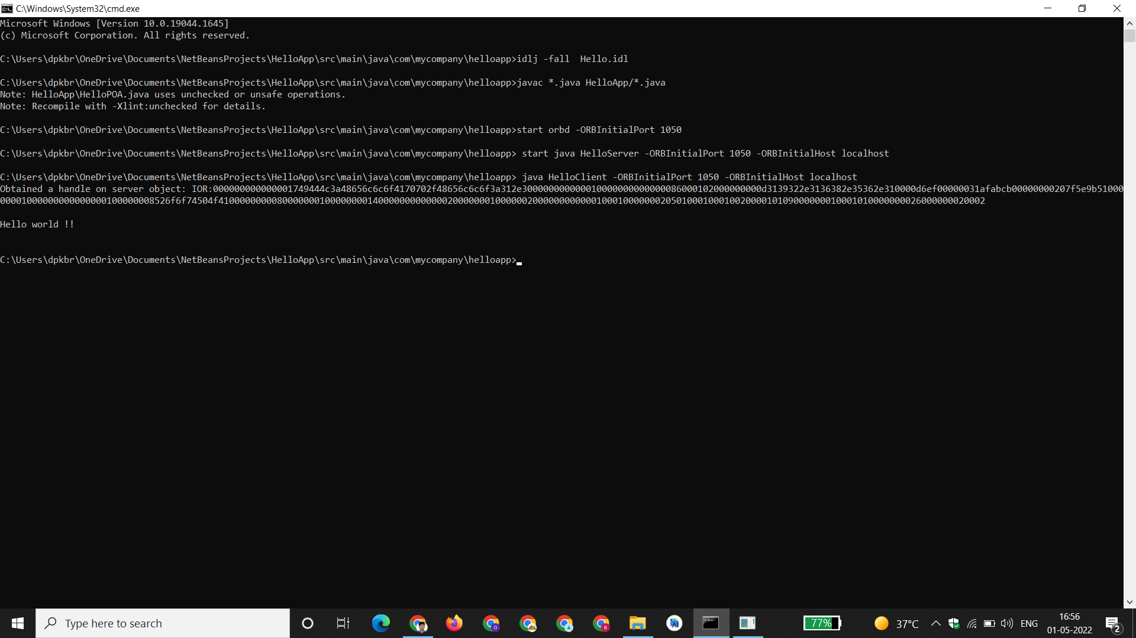

**Conclusion:**

CORBA provides the network transparency, Java provides the implementation transparency.

CORBA complements the Java™ platform by providing a distributed object framework, services to support that framework, and interoperability with other languages. The Java platform complements CORBA by providing a portable, highly productive implementation environment. The combination of Java and CORBA allows you to build more scalable and more capable applications than can be built using the JDK alone.